LOS BONITOS LTDA.
Rut: 78.150.434-2
Dirección: Av. Las Hualtatas #1243, Vitacura.

PACKING LIST
Invoice to: |  |  | Deliver to:
Supermarket Rayo ok  Houston #33, dallas, Estados Unidos. |  |  | Houston #33, dallas, Estados Unidos. |  |  | P/L Date: 18-08-2020
 |  |  |  |  |  | Invoice No: 150
Tel: 33322244433 |  |  | Tel: |  |  | Customer Ref:
Email: |  |  | Email:
Marks | Full description of goods |  | Kind of Package | Size L x W x H (cm) | Volume | Quantity | Net Weight (Kg) | Gross Weight (Kg)
Los Bonitos | Mermelada de rosa mosqueta |  | cajas | large | 30 x 30 | 14 cajas | 80 kilos | 80 kilos
 |  |  | TOTAL: |  |  |  |  | 28.900
INCOTERM: FOB
Country of origin:Chile
Currency:dólar
We declare that the above information is true and correct to the best of our knowledge. For and on behalf of the above named company.
 | 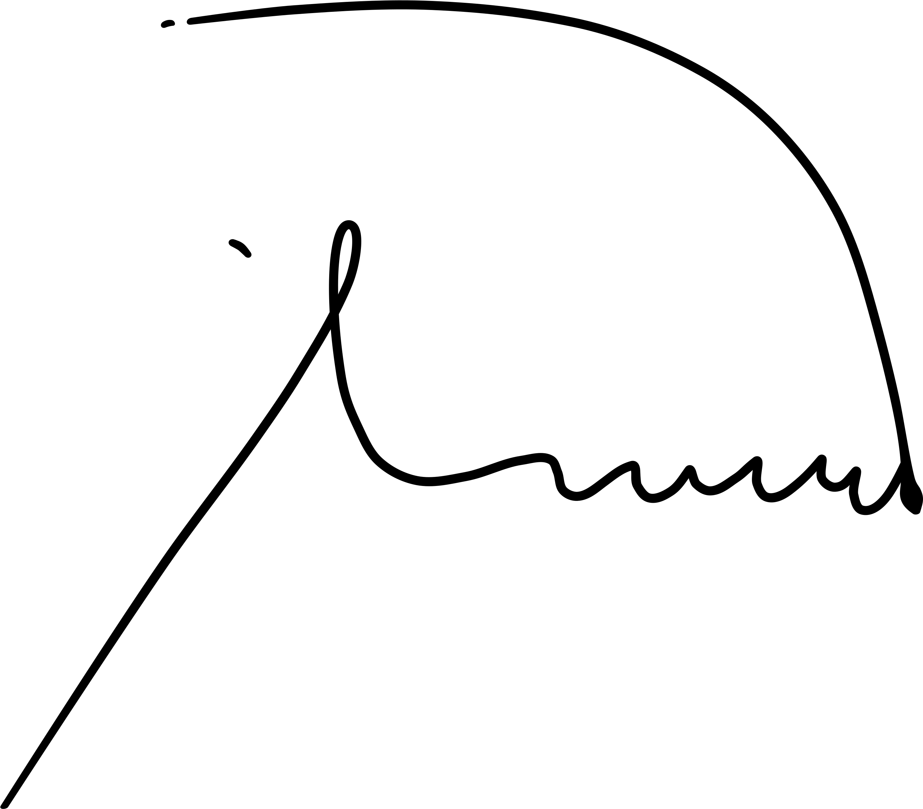
Signed…………...………

