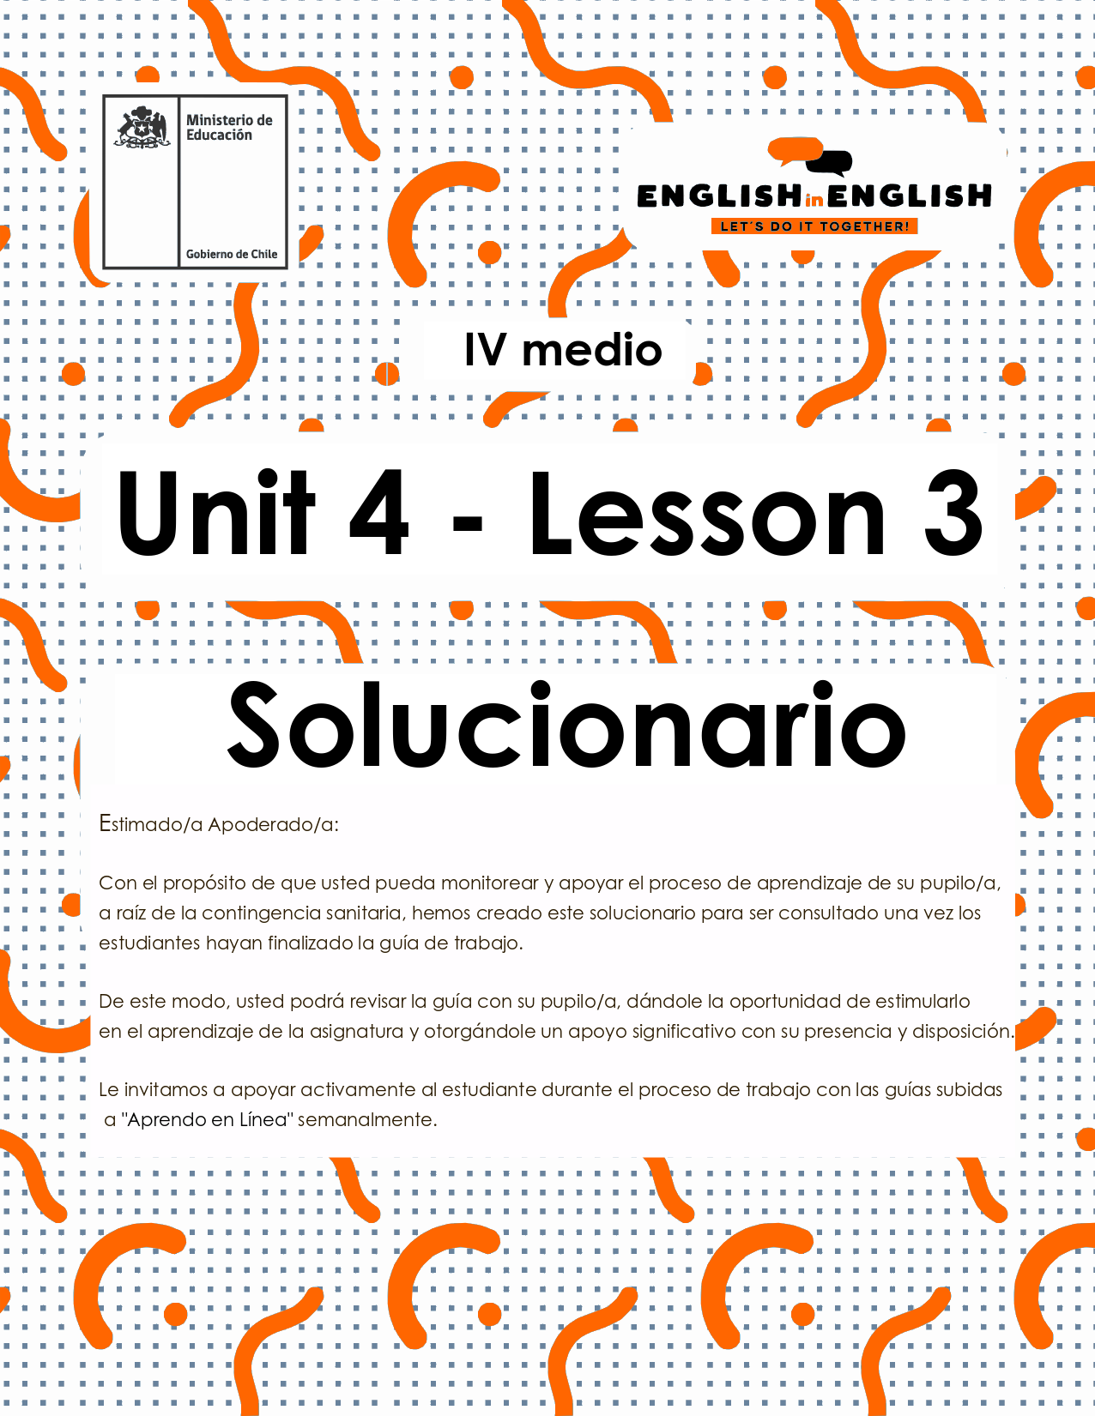

# ​UNIT 4 LESSON 3

GUÍA PARA USAR EL SOLUCIONARIO

1. **¿Qué es un solucionario?**

* Un solucionario incluye las respuestas a todas las preguntas y actividades.
* Algunas de las preguntas tienen más de una posible respuesta.
* Algunas de las preguntas tienen una sola respuesta.

1. **¿Cómo revisar mis respuestas?**

* Encontrarás títulos en los encabezados de los ejercicios que dicen “**answers”** en respuestas cerradas, y en el caso de respuestas abiertas encontraras un encabezado indicando “**answers may vary”.**

1. **Las respuestas en ejercicios de verdadero falso, llenado de tablas, unión de letras y dibujos, etc. pueden estar en:**

* **Negrita**
* Subrayado
* Sombreado con colores de formato de guía (purpura, verde, naranjo)
* Encerradas en círculos
* Destacadas
* ~~Tachadas~~

1. **Ejemplos de respuestas se ilustran a continuación:**



I) What is the first thing you think of when you look at it? Why?

**Answers may vary.**

Example: Art, music, painting. Because there are different people doing these activities.

II) Find the words to complete the sentences using the picture clues. For extra help you can use the Pictionary at the end.

a. The artists used **materials** like rubber, plaster and styrofoam to make their art.

b. Pomaire pottery is mainly made of **clay**. Don´t forget to visit this magical village!

## SECTION 1: SETTING THE CONTEXT

Hello Students, welcome back to lesson 3. In this lesson we will rehearse **writing** skills by considering the topic of ***successful technological gadgets***.

1. **Look at the following images of creative, innovative and successful technological gadgets and answer the following questions.**

. 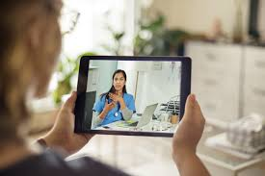

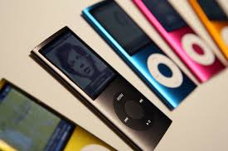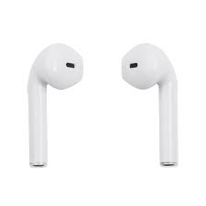

Answers may vary

1. Why do you think these gadgets are successful?

I think they are used for communication.

1. Which one would you consider the most creative one(s) and why?

The first one because it involves images and sounds.

1. Which one (s) would you consider the most innovative and why?

Number 4. It is a new kind of design.

1. Which one(s) do you like the most and why?

Number 1. I think it is cool and very useful.

1. **People say that the fastest-changing gadgets are cellphones. They started as very large devices to call other people and evolved into very small smartphones. Thinking of the evolution and change of this device, answer the following questions:**

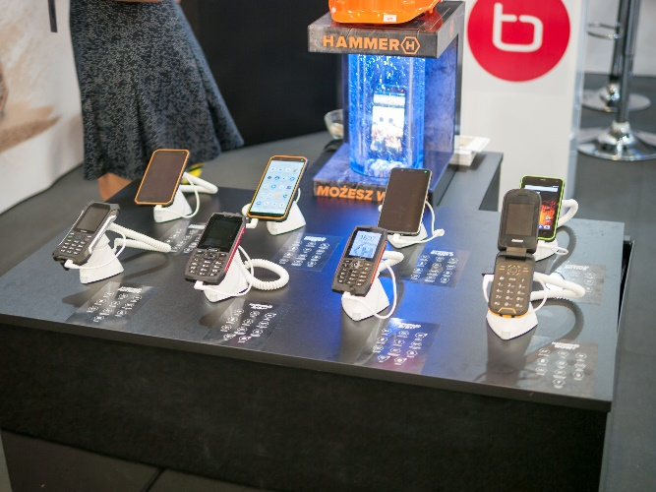

Answers may vary

* 1. When you change your phone, what do you look for in the new one?

I pay attention to camera and memory card capacities.

* 1. Does the brand and the model mean something for you to select a new phone? Please explain.

Yes, it does. I prefer purchasing a very well-known one.

No, I do not. I do not care about that. Y buy the most beautiful one for me.

* 1. What do you value the most, a low price cellphone that may not be as good as you think, or a very good quality cellphone that is more expensive? Why?

I prefer the second option. Quality is what I value the most.

## SECTION 2: LET’S PRACTICE

1. **For a gadget to be successful it needs to have several positive features. For example, it needs to be practical, it needs to be light and it needs to be economic. Read about these TOP innovative gadgets for cell phones and answer the following questions:**

Answers may vary

1. **Digital Highlighter**

This device works as a highlighter, but it's even better because it helps store the parts of the text you need to highlight in a digital format. So much for conventional highlighters!

|  |  |
| --- | --- |
|  | How would you use the digital highlighter for your studies?  I would use it to highlight lots of dates and memorize them |

### **Projector**

A smartphone projector! This is totally cool for those who prefer watching TV shows and movies on a small screen. Turn a wall in your room into a cinema – all you need is this amazing gadget!

|  |  |
| --- | --- |
|  | What would you project first using this gadget?  I would project my favourite movie, and I will watch it with my family |

### **Smartphone Sterilizer**

There have been many reports on how unhygienic smartphones are, so here is a whole new device to sterilize your gadget. Say bye-bye to bacteria!

|  |  |
| --- | --- |
|  | Can you give a good reason for using this device?  Well, I think the best reason is the pandemic |

### **Smartphone with keyboard projector**

Keyboard projectors are a new hit in the smartphone gadget industry. Some of the manufacturers have even introduced phones with this inbuilt technology

|  |  |
| --- | --- |
|  | Why would people be interested in buying this gadget?  Because it is creative and original |

Adapted from <https://gforgadget.com/best/smartphone-accessories-and-gadgets/>

1. **Create a list of positive features for gadgets to be successful in the market. Use the letters given to complete the features.**

Answers may vary

|  |  |  |
| --- | --- | --- |
| A successful gadget needs to be | **F** | Example. Fun |
| **R** | Reliable |
| **E** | Excellent |
| **B** | Best |
| **D** | Dynamic |
| **A** | Awesome |
| **U** | Useful |

1. **Now, it is time for you to create sentences by using the words your complete.**

Answers may vary

|  |  |
| --- | --- |
| **FUN** | Example. Gadgets are **fun**, I really love them! |
| **Reliable** | I only buy gadgets whose brand and quality are really **reliable.** |
| **Excellent** | Smartphones with a big screen are **excellent** for the elderly. |
| **Best** | For me, Japanese gadgets are the **best** ones at the market. |
| **Dynamic** | Example. Most gadgets for cars have a very **dynamic** design, that is why I love them. |
| **Awesome** | All Korean gadgets are just **awesome!** |
| **Useful** | That gadget is really **useful** and easy-to-use. |

1. “**Ballie**” was the most successful gadget this 2020. Read the text, look at the picture and give 2 reasons for Ballie’s success:

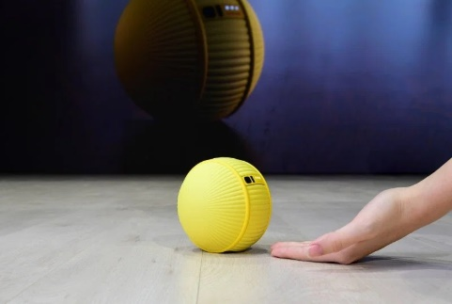

The worldwide famous Korean brand “Ballie” is an interesting combination between smart home device and robotic companion. The ball-shaped gadget, equipped with cameras and sensors used to follow you around, can control various smart home features, take photos, send you updates about your home when you’re away, and even function as a fitness assistant. Designed to be an “all-around life companion,” Ballie might be cute enough give your pup a run for its money.

Answers may vary

|  |  |
| --- | --- |
| Reason 1 for success | It is successful because the design and color are beautiful |
| Reason 2 for success | It is successful because it is a good companion and effective if you don´t have a good memory |

Taken from https://time.com/5761770/best-ces-2020/

## SECTION 3: LET´S CONSTRUCT AND APPLY OUR KNOWLEDGE

1. **For this week project. You need to create a handbook that includes key tips for a gadget to be successful, effective, innovative, etc.… For this,**

Answers may vary

* 1. Brainstorm as many positive adjectives you can in one minute.

|  |
| --- |
| Example,  Beautiful, colorful, flexible, light, beautiful, comfortable, cheap, easy to use, small, waterproof, ….. |

* 1. Make statements with the adjectives by using structure ***It needs to have + adjective***and the structure***It needs to be + adjective***

|  |
| --- |
| Example:    **It needs to have advanced technology it needs to be colorful!** |

C. Create your handbook with at least 8 tips. Use this template.

|  |
| --- |
| **My 10 tips handbook for a gadget to be successful**   1. It needs to have a good price. 2. It needs to be excellent quality. 3. It needs to have availability in all markets. 4. It needs to have different designs and colors. 5. It needs to be easy to use. 6. It needs to be waterproof 7. It needs to be comfortable 8. It needs to have a unique selling proposition. 9. It needs to be light 10. It needs to be colorful and attractive for young people |

## SECTION 4: Extra activity

1. Think about 2050 and make a drawing of the evolution of these gadgets and write one unique feature.

Answers may vary

|  |  |
| --- | --- |
| This Gadget in 2020 | Gadget Drawing for 2050 |
|  | Unique feature: it is water resistant |
|  | Unique feature: it stores 5000 movies and songs |
|  | Unique feature: it can be connected to the cellphone |