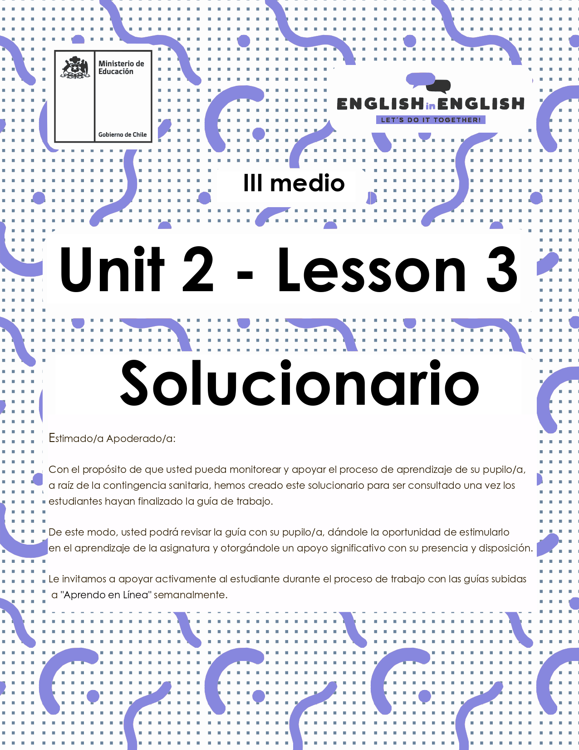

# UNIT 2 LESSON 3

## ÚTILES

* Texto del estudiante de 3° medio.
* Diccionario de inglés.
* Lápices.
* Cuaderno de asignatura.

## ICONS FOR ACTIONS

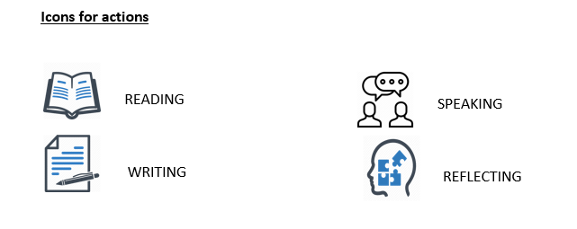

## SECTION 1: SETTING THE CONTEXT

## Welcome to lesson number 3! Now it is time to practice Writing skills. So, let´s get started!

1. **Do you recall some** opinions **or** facts **from lesson number 2 about reading?**

**- We worked on customs and traditions all over the world.**

**- Write down some ideas:**

## Fact(s):

## Students are attending online classes.

## We are currently in obligatory quarantine.

## Opinion(s):

## National holidays’ celebrations may be cancelled this year.

## Corona virus might end by the end of the year.

|  |
| --- |
| Sometimes it is not easy to discriminate what a fact or an opinion might be. How can you distinguish between them both? Remember! A **fact** is something that can be checked and backed up with evidence, while an **opinion** is based on a belief or view. |

1. **Considering that, write down some facts and opinions you may know about the following topics:**

|  |  |  |
| --- | --- | --- |
| Topic | Fact | Opinion |
| * **For example:** Europeans having Penpal friends. | It is commonly used by young people. | It can be hard for adults as it involves having certain TICs skills. |
| * Chilean teens backpacking across our country. * Americans celebrating “sweet 16” and Mexicans “quinceañera”. * Brazilians wearing white clothes during New Year´s Eve. | People practicing this must bring items like boots or a sleeping bag.  One tradition in sweet 16 birthday and “quinceañera” celebrations is the father-daughter dance.  To welcome in the New Year, Brazilian culture dictates for everyone to wear white as a sign of peace and prosperity. | Backpacking is just for young people.  It is an old-fashion tradition.  This is only superstition. I do not believe in that. |

Traffic signs are part of our culture. We use them to regulate the traffic and for preventing accidents. Let´s check your knowledge about traffic signs.

1. Look at the sign and underline the right alternative.

|  |  |
| --- | --- |
|  | 1. You should stop 2. You must stop 3. You might stop |

|  |  |
| --- | --- |
|  | 1. You must enter 2. You mustn't enter 3. You should enter |

|  |  |
| --- | --- |
|  | 1. You should park 2. You must park 3. You can park |

## SECTION 2: LET´S PRACTICE

1. **Read the following information about Ramon**

Ramon is a Chilean teenager who has traveled all over the world with his parents. At the age of 16 Ramon has many friends in different countries including China, Haiti, Russia, Colombia, Venezuela, among others. Yesterday, Ramon was chatting with his friend Konico from China about the things he **should** and **should not** do in China if he ever visited. Konico told him that in China:

* You **shouldn’t** talk about uncomfortable sensitive topics with strangers.
* You **shouldn't** show up in a house empty handed if you are invited.
* You **should** travel in licensed transportation services only.

**4.1 Using the information from Konico, write 5 sentences giving advice to foreigners who are visiting Chile:**

|  |
| --- |
| 1. Foreigners should pay in public transport system 2. They shouldn't drink alcoholic drinks on the street 3. Foreigners perhaps should not carry expensive items in some areas of the city 4. Maybe foreigners should buy a Sim Card when they arrive to Chile 5. They should never litter in the underground |

1. **Look at the key words that match each definition below:**

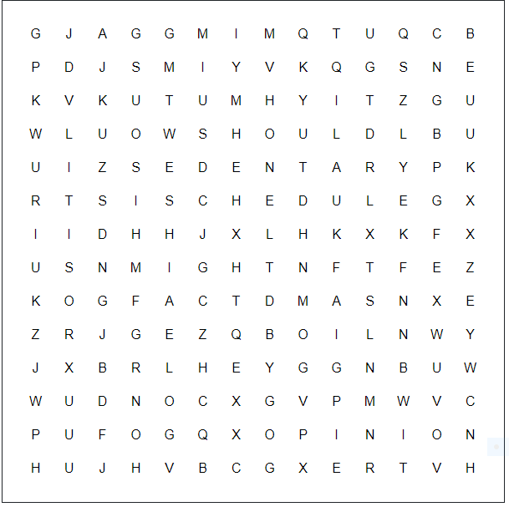

**5.1 Now, write the words below**

1. ____should ____is used for giving advice and recommendations.
2. ___might______is used to express (un) certainty.
3. ___fact______ _is something that can be checked.
4. ___opinion____is based on a belief.
5. ___sedentary __refers to someone who is not active.
6. ____schedule__indicates times and days for organization purposes.

**5.2 Finally, write original sentences with the words from the previous exercise:**

1. You should wash your hands every 2 hours
2. It might rain the whole weekend
3. Corona Virus is dangerous and can kill, and that is a fact
4. In my opinion you need to be clear to face the pandemic
5. I feel the quarantine is making me sedentary
6. I need a clear schedule to organize my work
7. **Do you remember the text from last week? It was about Italian teenagers and how they are living the quarantine in Italia.**

* The first teenager was Rami, and he said this:

|  |
| --- |
| *“I consider myself a very* ***sedentary*** *person. Usually during the school holidays, I tend to stay at home most of the time. Quarantine is not affecting what I would normally do with all this extra free time, and I know I must stay at home. One of the things that changed is my schedule. Since I don’t have to wake up at 6 am, I started to wake up later and later, and as a result I ended up having lunch, dinner, and going to bed at least two hours after my usual time, although I should go back to my usual* ***schedule****”.* |

**6.1 What do you think Rami *must* do about his schedule?**

He must go back to his old schedule and get more sleeping time

**6.2 What do you think Rami *should* do about his sedentary life?**

Rami should do more exercise/be more active

* **The next teenager was Alice, and she said:**

|  |
| --- |
| *“Staying at home is difficult, more than anything else, because I can’t see my friends in person, but I understand that going out might be dangerous for me and my family. Apart from not going to school and participating in extra-curricular activity, the only different thing is not going out with my friends”.* |

**6.3 What do you think *might* happen if you go outside during quarantine?**

It might be dangerous/I might get sick/Nothing might happen

**6.4 What do you think Alice *should* do with her friends when they meet again?**

They should go to the movies/they should have dinner together/they should eat something. Any activity would be ok, but the expected answer should include “should”.

* **The last teenager was Chiara, and she mentioned this:**

|  |
| --- |
| *“Obviously, I miss my friends and going out, but I* ***get along*** *well with my family and maybe I’ve always been a bit lazy, so adapting wasn’t difficult. Instead of going out with friends, on Saturday nights, I watch movies or series with my family, something nobody had time to do before. I spend most of my days studying, but I also have virtual meetings and chat with my friends, but physically it is different, and I miss that aspect.*  *At first it took me a while to know what was really happening, but I’m optimistic: if we all respect the rules and stay at home, we will be able to get out of this situation”.* |

**6.5 What do you think *may* happen with “movie time” when Chiara’s family go back to their normal routine?**

Movie time may be over/end

**6.6 What rules you must follow during quarantine?**

Any commonly mentioned rules would be ok, such as, staying at home, wearing a face mask, washing your hands for 20 seconds or more, clean the house, leave your shoes outside the door if you leave your house, etc.

## SECTION 3: LET´S CONSTRUCT AND APPLY OUR KNOWLEDGE

**7. Imagine you are invited to post an article at a digital international travel magazine.**

**- The invitation involves including some** pieces of advice **when a foreigner may want to visit Chile.**

**- What would you** suggest **him or her doing?**

**- Use the following prompts:**

* Time of the year and climate
* Travel documents like passport, visa, entry fee, parental ones, etc.
* Main tourist attractions
* Local traditions and Chilean culture

You may start with something like “*To visit Eastern Island in February for the Tapati Rapa Nui celebration, first you* ***must*** *have a valid passport to get to Chile first. Second, you* ***should*** *bring summer clothes and diving equipment if you* ***might*** *practice some water sports. Also, you must not harm or destroy historical sites like the Moai at Rano Raraku...*

*In general, Rapa Nui is a very safe island for travellers. Related to vaccinations to get there, it is not necessary to have a mandatory one so you should not worry about it.*

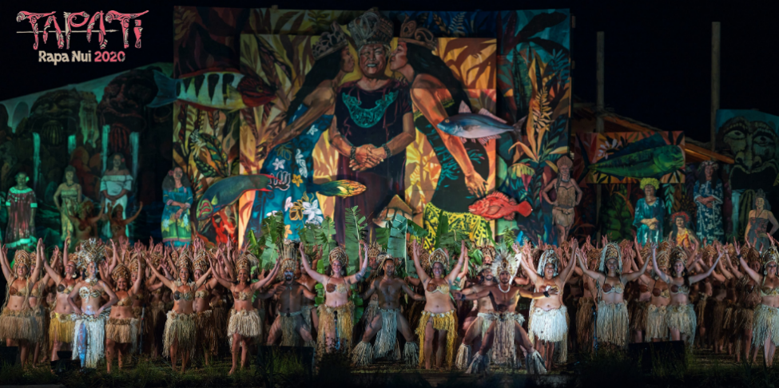

## SECTION 4: EXTRA ACTIVITY

**8. Can you tell us about your quarantine life?**

**- Please write a short paragraph about you.**

**- Start by introducing some facts about you, and then continue with some opinions or predictions you *may* have.**

**- You can answer these questions to have an idea:**

* What is your name? The name of the students
* Where are you from? The place where the student lives
* What is your favorite activity? Any activity would be ok
* How have you been feeling lately? Any type of feeling would be ok
* What good advice can you give to other teenagers who are living in quarantine in this moment? Remember to use *“should”.* Any type of advice would ok, for example, “teenagers should eat healthy and take some time to study”.
* What do you think *may* or *might* happen to you in this school year? Any type of answer regarding this school year would be ok, for example, “I think I might not come back to classes” or “I think I may learn more on my own”.