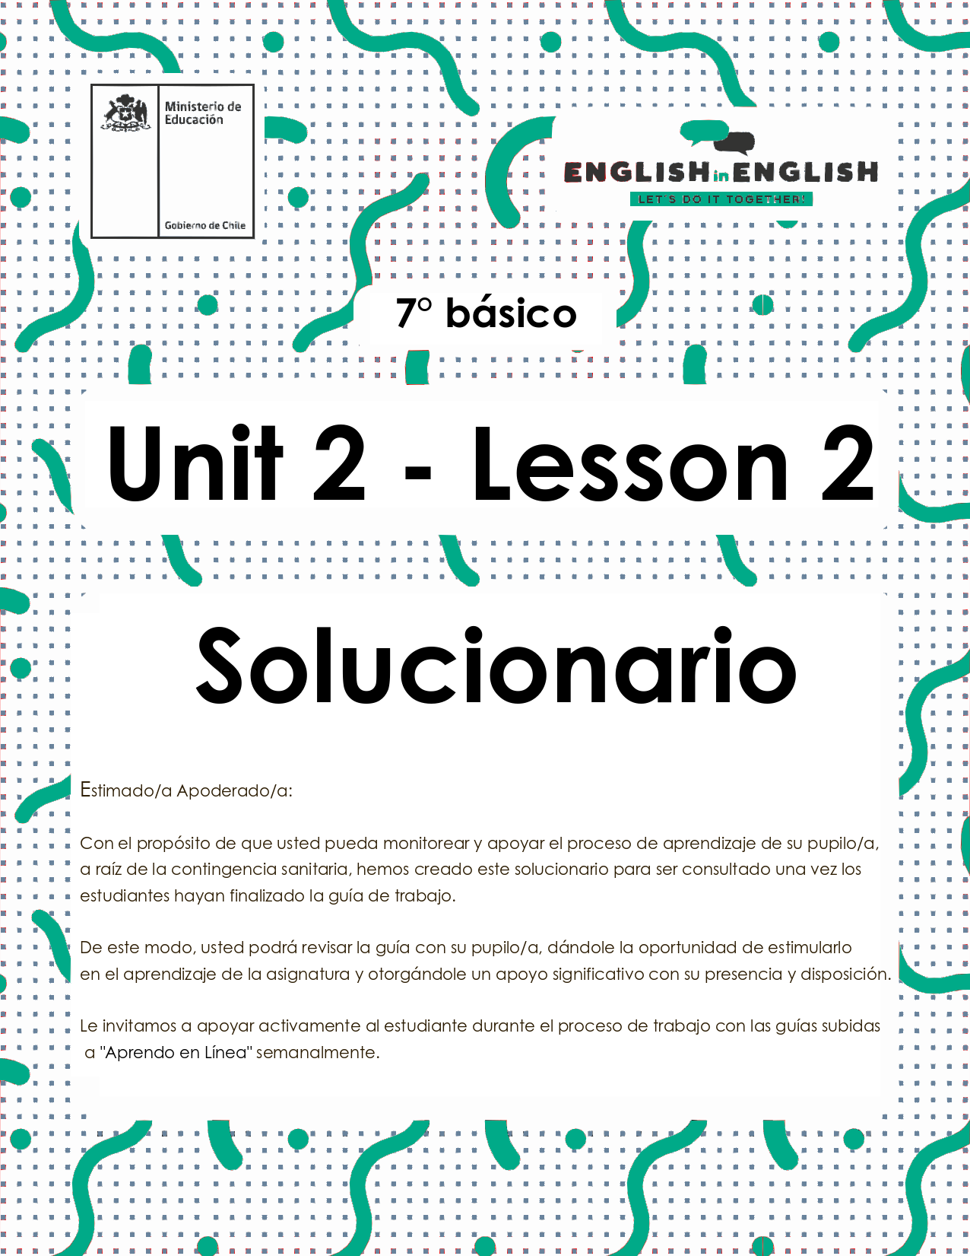

UNIT 2  
LESSON 2

## ÚTILES RECOMENDADOS:

* Texto del estudiante 7° básico.
* Cuaderno de inglés o 2 hojas en blanco.
* Lápiz grafito y goma.
* Diccionario de Inglés físico / online <https://dictionary.cambridge.org/es/diccionario/espanol-ingles/>

## SECTION 1: SETTING THE CONTEXT

## Cooking

**1. Observe the image and answer the questions.**

* Observa la imagen y responde las preguntas.

1. Se aceptan respuestas como: A person cooking, a chef, cooking utensils, vegetables.
2. Todas las respuestas son correctas.
3. Tomatoe, eggplant, green onion.
4. Healthy food recipe.
5. Todas las respuestas son correctas.

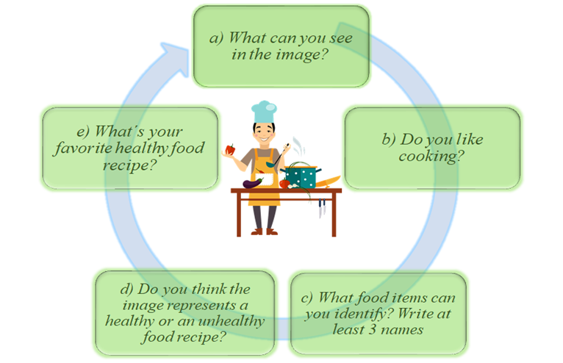

**2. Observe the images and match them with the corresponding verbs.**

* Observa las imágenes y únelas con los verbos correspondientes.

|  |
| --- |
| cut - peel - mix - shape - heat - slice - place - cook - cover - serve |

|  |  |  |  |  |
| --- | --- | --- | --- | --- |
|  |  |  |  |  |
| cut | cook | peel | slice | heat |
|  |  |  |  |  |
| place | serve | mix | shape | cover |

**3. What do you think you will read ? Choose an alternative.**

* ¿Qué crees que leerás? elige una alternativa...

1. a story b) a recipe 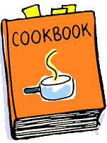 c) an email  d) a letter 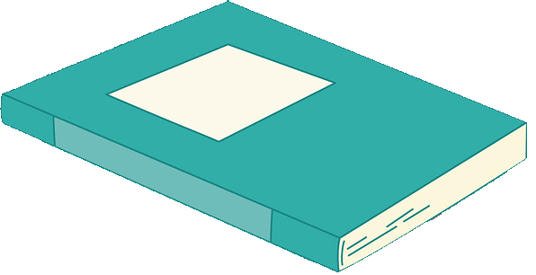

## SECTION 2: LET´S PRACTICE

## Recipes

**1. Read the texts quickly and answer the questions.**

* Lee los textos rápidamente y responde las preguntas.

1. What type of texts are these? 2 recipes
2. Which one do you think is a healthy recipe? Greek Salad
3. Which one do you think needs more ingredients? My favorite burger

My Favorite Burger

Ingredients:

* 500g of beef
* 2 tablespoons of mustard
* 1 tablespoon of onion powder
* 1 tablespoon of garlic powder
* 1 tablespoon of salt
* 1 tablespoon of fresh pepper

Preparation:

***1.*** Mix all the burger ingredients together just until combined. Don’t overwork the meat.

***2***. Shape into 4 patties by creating a ball and then using the bottom of a plate to “squish” it down. Make a thumb print in the middle so the patty keeps its shape when frying.

***3.*** Heat a griddle pan, frying pan or BBQ to med-high and place the burger in the pan.

***4.*** Cook 4 minutes then flip and place your cheese on top. Cover the pan and cook for another 4 minutes.

***5***. Let the burger rest for 5 minutes before serving. Meanwhile toast only the inside of your bun by placing it on top of the toaster. Once the burger has rested, place on bun with toppings of your choice and enjoy.

* Toppings:
* Mayonnaise
* Ketchup
* A slice of cheese
* Lettuce
* Tomato
* Pickles

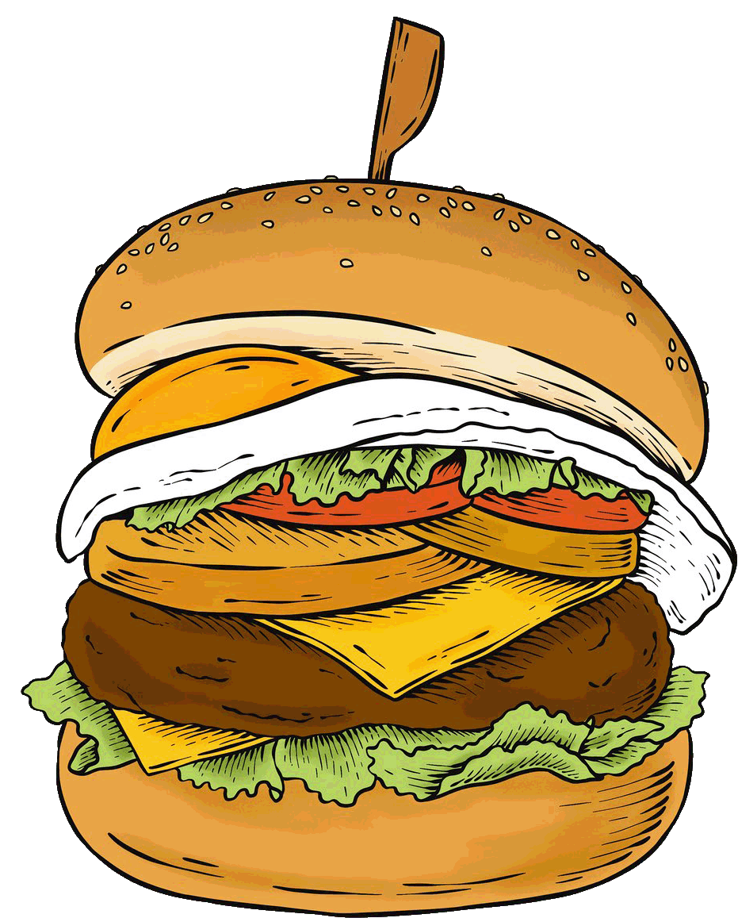

Greek Salad

Ingredients:

* 250g cherry tomatoes
* 1 medium onion
* 1 medium cucumber
* 150g cheese
* 3 tablespoons of olive oil
* 1 tablespoon of vinegar
* 1 chopped clove of garlic
* Salt and pepper

Preparation:

***1.*** Cut tomatoes in halves, peel and dice the cucumber and slice the onion and place them in a bowl.

***2.*** Mix oil, vinegar, garlic, salt and pepper, pour it over the vegetables.

***3.*** Add crushed cheese on top.

***4.*** Serve and enjoy it!

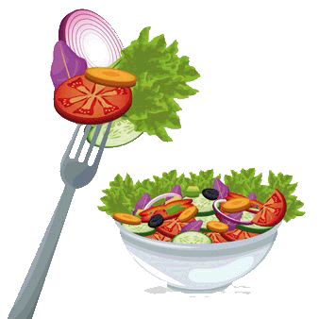

**Vocabulary**

|  |  |  |  |  |  |  |  |  |
| --- | --- | --- | --- | --- | --- | --- | --- | --- |
| |  |  |  |  | | --- | --- | --- | --- | | Tablespoon: cuchara sopera | patties: croquetas | squish: aplastar | bun: bollo | | Toppings: aderezos | chopped: cortado en trocitos | crushed: aplastado | clove of garlic: diente de ajo |   Text taken from [tamaras-table.com/2017/01/17/ts-burger/](https://tamaras-table.com/2017/01/17/ts-burger/)  <https://en.islcollective.com/english-esl-worksheets/search/recipes> |

**2. Read the texts again and underline all the food items you can find.**

* Lee los textos nuevamente y subraya todas las palabras relacionadas con alimentos que puedas encontrar.

3. **Read the recipe about Greek Salad and complete the sentences with the words from the box.**

* Lee la receta sobre Greek Salad y completa las oraciones con las palabras de la caja.

|  |
| --- |
| * **First** * **Second** * **Next** * **Finally** |
| Greek Salad  **First**Cut tomatoes in halves, peel and dice the cucumber and slice the onion and place them in a bowl.  **Second**Mix oil, vinegar, garlic, salt and pepper, pour it over the vegetables.  **Next** Add crushed cheese on top.  **Finally**Serve and enjoy your salad. |

**4. Read the recipe about “My Favorite Burger” and complete the sentences with the corresponding verb.**

* Lee la receta sobre “My Favorite Burger” y completa las oraciones con el verbo correspondiente.

|  |
| --- |
| **mix - shape - heat - place - cook** |

1. **heat** a griddle pan, frying pan or BBQ to med-high.
2. **mix** all the burger ingredients together just until combined.
3. Once the burger has rested **place** on bun with toppings of your choice.
4. Cover the pan and **cook** for another 4 minutes.
5. **shape** into 4 patties by creating a ball.

**5. Read both recipes (Greek Salad and My Favorite Burger) again and complete the table.**

* Lee ambas recetas (Greek Salad y My Favorite Burger) nuevamente y completa la tabla.

|  |  |  |
| --- | --- | --- |
| ***Questions*** | ***Greek Salad*** | ***My Favorite Burger*** |
| *How many ingredients are necessary? Write a number* | *8* | *12* |
| *Is this a healthy or an unhealthy recipe?* | *Healthy recipe* | *Unhealthy recipe* |
| *Does it require a lot of time preparation?* | *no* | *yes* |
| *Does it use an oven?* | *no* | *yes* |
| *What kind of vegetables are necessary? Write them* | *Cherry tomatoes, onion, cucumber, garlic* | *Lettuce, tomato* |

## SECTION 3: LET´S CONSTRUCT AND APPLY OUR KNOWLEDGE

## My own recipes

**1. Read the recipe “My Favorite Burger” again and make healthy changes to its ingredients and preparation.**

* Lee la receta “My Favorite Burger” nuevamente y haz cambios saludables a sus ingredientes y preparación.

|  |
| --- |
| * RESPUESTA: Todas las respuestas son correctas siempre y cuando se incluyan alimentos saludables en la segunda columna.  En la columna de “my favorite burger” debe copiarse los ingredientes y preparación señalados en el texto. |

|  |  |  |
| --- | --- | --- |
|  | ***“My favorite burger” recipe*** | ***Healthy recipe*** |
| ***Ingredients*** | 500g of beef, 2 tablespoons of mustard, 1 tablespoon of onion powder, 1 tablespoon of garlic powder, 1 tablespoon of salt ,1 tablespoon of fresh pepper. Toppings: Mayonnaise, Ketchup, a slice of cheese, Lettuce, Tomato, Pickles. |  |
| ***Preparation*** | Mix all the burger ingredients together just until combined. Don’t overwork the meat.  ***2***. Shape into 4 patties by creating a ball and then using the bottom of a plate to “squish” it down. Make a thumb print in the middle so the patty keeps its shape when frying.  ***3.*** Heat a griddle pan, frying pan or BBQ to med-high and place the burger in the pan.  ***4.*** Cook 4 minutes then flip and place your cheese on top. Cover the pan and cook for another 4 minutes.  ***5***. Let the burger rest for 5 minutes before serving. Meanwhile toast only the inside of your bun by placing it on top of the toaster. Once the burger has rested, place on bun with toppings of your choice and enjoy. |  |

**2. Choose your favorite food and write the recipe considering these aspects.**

* Elige tu comida favorita y escribe la receta considerando estos aspectos.

|  |
| --- |
| RESPUESTA: Todas las respuestas son correctas porque son personales. |

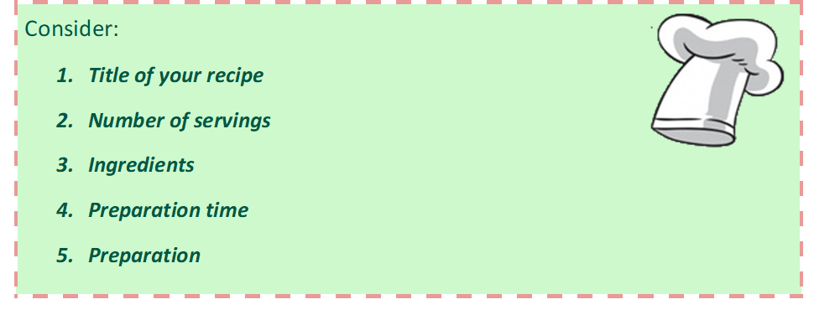

|  |
| --- |
| **Recipe** ……………………………………..  **Ingredients:**  ……………………………………………………………... ………………………………………………………...  ………………………………………………………........ ………………………………………………………...  ……………………………………………………………... ………………………………………………………...  ………………………………………………………........ ………………………………………………………...  **Servings**…………………………………………….  **Prep time**…………………………………………….    **Preparation**  ……………………………………………………………………………………………………………………………………………………………………………………………………………………………………………………………………………………………………………………………………………………………………………………………………………..  …………………………………………………………………………………………………………………………………………………………………………………………………………………………………………………………………………………………………………………………………………………………………………………………………………………………………………………………………………………………………………………………………………………… |

## SECTION 4: EXTRA ACTIVITY

## Describing my meal

**Look at the 2 cards about food and how to cook something. Choose one and describe it according to the information requested. Then you can share it with your family.**

* Mira las dos tarjetas sobre comida y como cocinarlas. Elige una y descríbela de acuerdo a la información requerida. Luego puedes compartirla con tu familia.

|  |
| --- |
| RESPUESTA: Todas las respuestas son correctas porque son personales. |

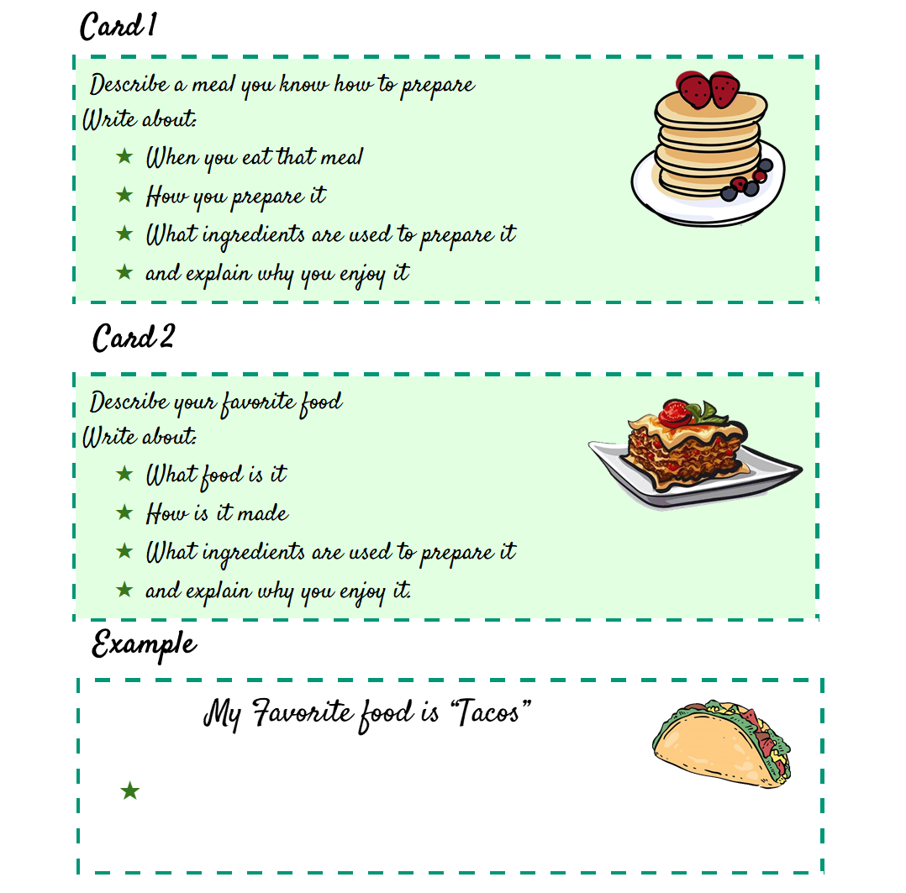

Example:

SECTION 5: DIGITAL RESOURCES

Take a look at this link!

* <https://bdescolar.mineduc.cl/info/delicious-dairy-recipes-00045836>

Share it with your friends through social media and  **eodp_chile /**  **Students in Action.**

## 

## NO OLVIDAR REPASAR EL CONTENIDO CON UN ADULTO