

PAUTA JUEGO: VIAJE AL ESPACIO

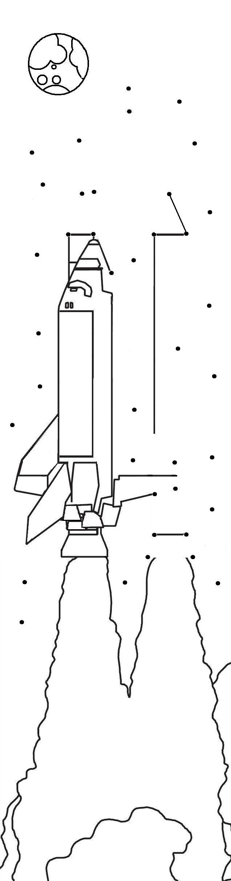
1. |  | 6 | 3 | 8 | 1 |  | 2. |  | 4 | 9 | 0 | 3
 | + | 2 | 1 | 7 | 9 |  |  | + | 2 | 5 | 7 | 9
 |  | 8 | 5 | 6 | 0 |  |  |  | 7 | 4 | 8 | 2
3. |  | 1 | 0 | 9 | 6 |  | 4. |  |  | 9 | 3 | 4
 | + | 7 | 4 | 8 | 5 |  |  | + | 8 | 7 | 1 | 9
 |  | 8 | 5 | 8 | 1 |  |  |  | 9 | 6 | 5 | 3
5. |  | 5 | 5 | 2 | 8 |  | 6. |  | 3 | 6 | 3 | 8
 | + | 1 | 7 | 6 | 4 |  |  | + | 4 | 2 | 6 | 9
 |  | 7 | 2 | 9 | 2 |  |  |  | 7 | 9 | 0 | 7
7. |  | 2 | 6 | 6 | 6 |  | 8. |  | 6 | 1 | 1 | 9
 | + | 3 | 7 | 8 | 5 |  |  | + | 1 | 9 | 9 | 7
 |  | 6 | 4 | 5 | 1 |  |  |  | 8 | 1 | 1 | 6
9. |  | 5 | 9 | 3 | 6 |  | 10. |  | 6 | 1 | 0 | 9
 | + | 2 | 4 | 7 | 4 |  |  | + |  | 9 | 4 | 7
 |  | 8 | 4 | 1 | 0 |  |  |  | 7 | 0 | 5 | 6
11. |  | 4 | 5 | 6 | 3 |  | 12. |  | 5 | 4 | 5 | 5
 | + | 2 | 7 | 4 | 6 |  |  | + | 1 | 3 | 7 | 5
 |  | 7 | 3 | 0 | 9 |  |  |  | 6 | 8 | 3 | 0
13. |  | 6 | 2 | 7 | 7 |  | 14. |  | 4 | 5 | 5 | 8
 | + | 1 | 4 | 7 | 8 |  |  | + |  | 8 | 6 | 3
 |  | 7 | 7 | 5 | 5 |  |  |  | 5 | 4 | 2 | 1
15. |  | 2 | 3 | 7 | 8 |  | 16. |  | 2 | 2 | 2 | 2
 | + | 3 | 5 | 6 | 9 |  |  | + | 3 | 3 | 3 | 3
 |  | 5 | 9 | 4 | 7 |  |  |  | 5 | 5 | 5 | 5

5555
7482
8560

8581
9653
7292
6451
8116
8410
7056
7309
6830
7755
5421
5947
7907
1234
6789
6767
5109
7734
3450
5098
2345
7777
4677
8999
7881
9081
990

9834
567
7689
1121
9001
6755

Elaborado por: Beatriz Villagrán Walter

